HCV Test Result Log

Agency Name: ________________________________ Site: _________________________________ Worker Name: __________________________ rev. 5.2018

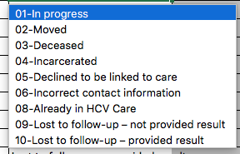
Unique Client  ID | Year of Birth | Rapid HCV Antibody Testing QA |  |  |  |  | Ab Test Result  N =  Non-reactive  R = Reactive*  I = Invalid | RNA Test Result  N = Negative/ Undetectable  P = Confirmed Positive  I = Invalid | Date  Client Received RNA Results | Linked to Care | Why not linked?
 |  | Room Temp | Date/Time Specimen  Collected | Rapid  Test Lot Number | Rapid Test Expiration Date | Time  Result Read |  |  |  | Date RNA+ Client attended:  E = HCV Education  and/or  First Medical Appointment:  P = Primary Care  S = Specialty Care | See Legend Below

* Reactive or HCV antibody positive.
All Ab+ tests must be confirmed with an RNA/viral load test to determine whether the client is infected with hepatitis C.

